From: <http://davidstockmanscontracorner.com/keynesian-central-bankers-the-useful-idiots-of-bubble-finance-part-3/>

Feb 5, 7, & 8. Search" "Useful Idiots of Bubble Finance" "The idiocy of r*" "The idiocy of rstar" rstar

Keywords: "[Buy the DIP.](https://www.google.com/search?q=buy+the+dip&oq=buy+the+dip&aqs=chrome..69i57.3870j0j8&sourceid=chrome&ie=UTF-8)",

**Keynesian Central Bankers---The Useful Idiots Of Bubble Finance, Part 3**

**By David Stockman. Posted On Friday, February 8th, 2019**

The chart monkeys were slipping and sliding again today for the third session in a row---rescued only by a blatantly obvious stick save in the last minutes of trading. So we doubt very much that they are done buying the dip.

In hockey, a crude but effective save where the puck is diverted not with the end of the curved stick but with the handle. The player simply falls on the ice or bats at the puck with the stick. No points for style, and often fails, but a save is a save.

In other contexts, whenever a "player" manages to pull out a situational "save" at the last instant via reckless, feckless or random methods. As in financial markets, when institutions manage to move the market up in the last minutes of trading thus ensuring an "up" day, even though a "down" day was in the making.

Did you see the 100 point stick save in the run up to the market bell? You gotta give the PPT credit, that was a thing of beauty.

That's because after decades of Keynesian central banking predicated on "wealth effects" and stock market price-keeping, the risk/reward equation has been asymmetrically skewed and drastically so. Other than the big, violent flushes which seem to be triggered by a Black Swan every 7-10 years, there is a defined, shallow bottom to chart-based trading cycles.

Consequently, there is virtually zero risk in buying the dip because putting a floor under risk asset trading cycles is now embedded in the reaction function of the Fed and other central banks.

That is to say, during these "dip" style sell-offs financial conditions allegedly "tighten" as measured by widening spreads in the corporate and junk bond markets, elevated volatility, liquidation of market leading momo stocks, a sharp break in the broad market averages and a flight to safety in the government bond market.

In an honest and un-manipulated free market, of course, this combination of developments in the trading pits would have no predictable pattern. It would represent price discovery in action and its depth and duration would depend upon the market's assessment of the outlook for the economy and profits at any given point in time.

Accordingly, if the assessment of millions of traders turned out benign, the dip might well be shallow, followed by a resumption of rising market averages. And if the outlook for economic growth and profits had turned decidedly darker, the correction might well be deep, long-lasting and fraught with uncertainty as to what comes next.

In either case, there would be no robo-machines and day traders instantly latching on to dovish cooing utterances from a Fed head; and there would be no latter-day Kremlinologists flyspecking trivial word changes (e.g. "firm" vs. "strong") in the absolutely vacuous post-meeting statements of the FOMC.

Among other reasons, as we shall address later, there would be no FOMC even present in free markets performing***honest***price discovery. After all, the essential purpose of the FOMC is to force ***dishonest*** price discovery into the Wall Street casino.

Moreover, after decades of that kind of plenary intrusion and falsification of financial asset prices, the Fed has even institutionalized an Orwellian doublespeak that completely smoothers any residual impulse toward two-way trading.

That is, if the market slides into a dip on the perception that risk spreads are too narrow or stock prices are too high, this is not only proclaimed to be a "tightening of financial conditions" by the central bankers, but also the decimal point equivalent of an increase in the targeted "policy" rate.

Needless to say, that blatant expression of false equivalence was perfected during the Bill Dudley (B-Dud) era as head of the New York Fed; and from there it rapidly infected the vocabulary of the flock of so-called economists and strategists who function as Fed minders and proctors in behalf of the Wall Street trading desks.

On cue, therefore, these Wall Street minders proclaim the inherent tightening of financial conditions during a dip amounts to the equivalent of 25 or 50 basis points of policy rate increase---the implication being that the casino has performed its own "selfie" rate hike.

In turn, these market-based rate hike selfies elicit word clouds from the Eccles Building about the need for the Fed to stand pat "lower for longer" if it is already on or near the zero bound; or to "pause" if a so-called interest target raising cycle is underway.

Upon the Fed's "all clear" in either event, a rambunctious dip-buying spree commences like the 16% rebound during the less than 30 trading days since the Christmas Eve bottom.

As we indicated in Part 2, these chart monkey acrobatics are not a form of harmless indoor sport enjoyed by the boys and girls domiciled in the Wall Street casino.

To the contrary, the Fed has completely broken the financial markets and eviscerated two-way trade and free market discipline. So doing, it has transformed the money and capital markets into a veritable devil's workshop of unhinged speculation, and a one-way asset pricing ratchet that eventually causes the stock averages to completely decouple from any semblance of the main street economy or rational valuation of GAAP earnings.

At length, of course, we get the 7-10 year Big Flush in the stock averages. At these junctures, all is forgiven as hundreds of billions of bad assets, impaired M&A goodwill and redundant workers and inventories are thrown overboard by the desperate C-suites of corporate America. Offering up these sweeping "restructuring" plans, they aim to appease the trading gods in the casino and to sterilize their balance sheets for another cycle of financial engineering and allegedly booming "ex-items" earnings.

**Just yesterday we had a screaming case of the speculative madness that builds up in the trading pits during these extended cycles of buy-the-dip escalation.** We are referring to the 14% surge in the failed once and former momo star, Chipotle (CMG).

As it has happened, Chipotle has been struggling for several years in the brackish waters at the end of a pell mell store opening process. The latter had resulted in loss of control over local operations and food quality---such that Chipotle suffered serial incidents of customer food poisoning over several years, and a huge hit to its brand image and store traffic.

Nevertheless, on the basis of a modest up-tick in store traffic (2%), overall sales growth (10.4%) and improved store level margins (17.0% vs. 14.9% in prior year) during the quarter, the momo speculators pronounced redemption has been had, and piled into the stock based on "blockbuster" earnings for Q4 2018.

Well, not exactly, at least according to the company's own press release that was written to satisfy a once-over from the SEC watch-puppies:

*Diluted earnings per share was $1.15, a****25.8% decrease****from $1.55. Adjusted diluted earnings per share was $1.72, excluding the impact of restaurant closure costs, corporate restructuring, and certain other costs,****a 11.0% increase****from $1.55.*

In the ex-items culture of the casino, obviously, down is the new up. A  failed, floundering ex-momo star reports a 26% drop in earnings, which are magically transformed into a 11% gain after excluding all the bad stuff, and the stock is off the races.

We even heard one of the noontime show knuckleheads on CNBC pumping the stock on the grounds that there are blue skies ahead for margins and sales, and that CMG's earnings are is still "attractively valued".

Well, it did post full year earnings of ***$176.3 million***, meaning the math of the thing is this: At today's closing price, CMG's market cap weighed in at ***$16.2 billion***, thereby sporting a PE multiple of ***92X!***

Worse still, even if you are drinking the ex-items Cool-Aid and ignore restaurant closure costs, corporate restructuring expense, assent impairments and disposals, employee severance, duplicate rents and consultant charges for all of these items and much more, adjusted net income clocked in at just ***$253 million.***

That is to say, you get to pay ***64X*** the kind of adjusted earning you would go to jail for if you reported them on your official income statement filed with the SEC. And when it comes to legal GAAP earnings, you were  actually buying the same net income number that the company reported way back in***2010.***

That's right. After hitting its momentum peak in September 2015 on the back of doubling it store count from about 1,000 in 2010 to 2,000 in 2015, the aforementioned food poisoning and operational control disaster crushed the company's consolidated operating margins from 16-17% range to under 7%, causing its net income to plunge commensurately.

Needless to say, the slight up-tick in margins during recent quarters depicted below does not amount to redemption by any stretch of the imagination.

And it most certainly does not warrant a ***64X-92X PE***multiple, as you please, for a burrito bowl vendor which has seen its better days; and which is surrounded by endless waves of competitive openings funded by the very same cheap debt and leases that permitted CMG's store count to soar in its heyday.  
[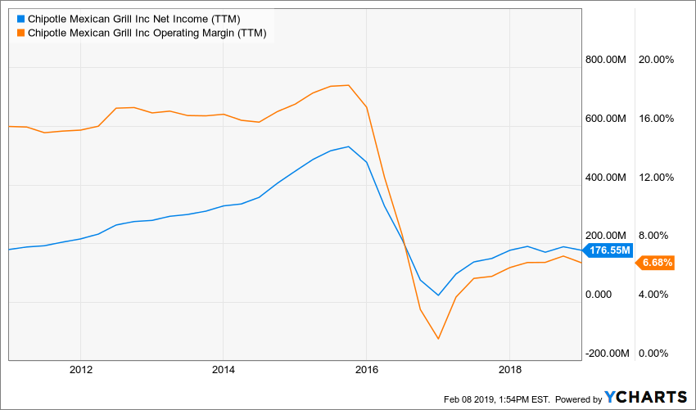](http://ycharts.com/companies/CMG/chart/#/?zoom=custom&useEstimates=false&annualizedReturns=false&source=false&legendOnChart=true&securitylistSecurityId=&securitylistName=&securities=id:CMG,include:true,,&quoteLegend=true&useHttps=false&scaleType=linear&dateSelection=range&correlations=&splitType=single&securityGroup=&calcs=id:net_income_ttm,include:true,,id:operating_margin_ttm,include:true,,&units=false&partner=&format=real&note=&quotes=true&recessions=false&title=&annotations=&startDate=12/31/2010&displayTicker=false&endDate=&chartType=interactive&maxPoints=850)

Indeed, the US restaurant sector is so massively overbuilt that the store count has actually begun to shrink in the last several years---after growing from 400,000 in the mid-1990s to 662,000 at the 2015 peak.

Needless to say, store count shrinkage after that massive growth run is a sign of acute congestion and margin-suffocating pressures to hold down prices; and  also to more heavily invest in store operations, advertising and marketing, store upgrades and facelifts etc. in order to keep up with the competition and compete with the massive expansion of venture capital funded home delivery and meal kit operations which have spring up in the last half decade.

What is doesn't suggest is that a mature and troubled operator in a mature industry with a 2.1% growth rate after inflation since the pre-crisis peak in 2007 should be valued at the absurd multiples depicted above.

In fact, this once and former high flyer has grown nominal sales at just 4.1% annually since 2014 or barely the nominal growth rate of the entire industry---including hundreds of thousands of mom and pop and non-chain standalone operations.

So what earthly reasoning would suggest that the CMG's $4.87 billion of revenues in 2018 should be valued at $16.3 billion or at 3.5X the sales of a company that has suffered massive margin compression during that same 4-year period; and which has no obvious way to recapture it former profit rates---especially in light of steadily rising labor costs?

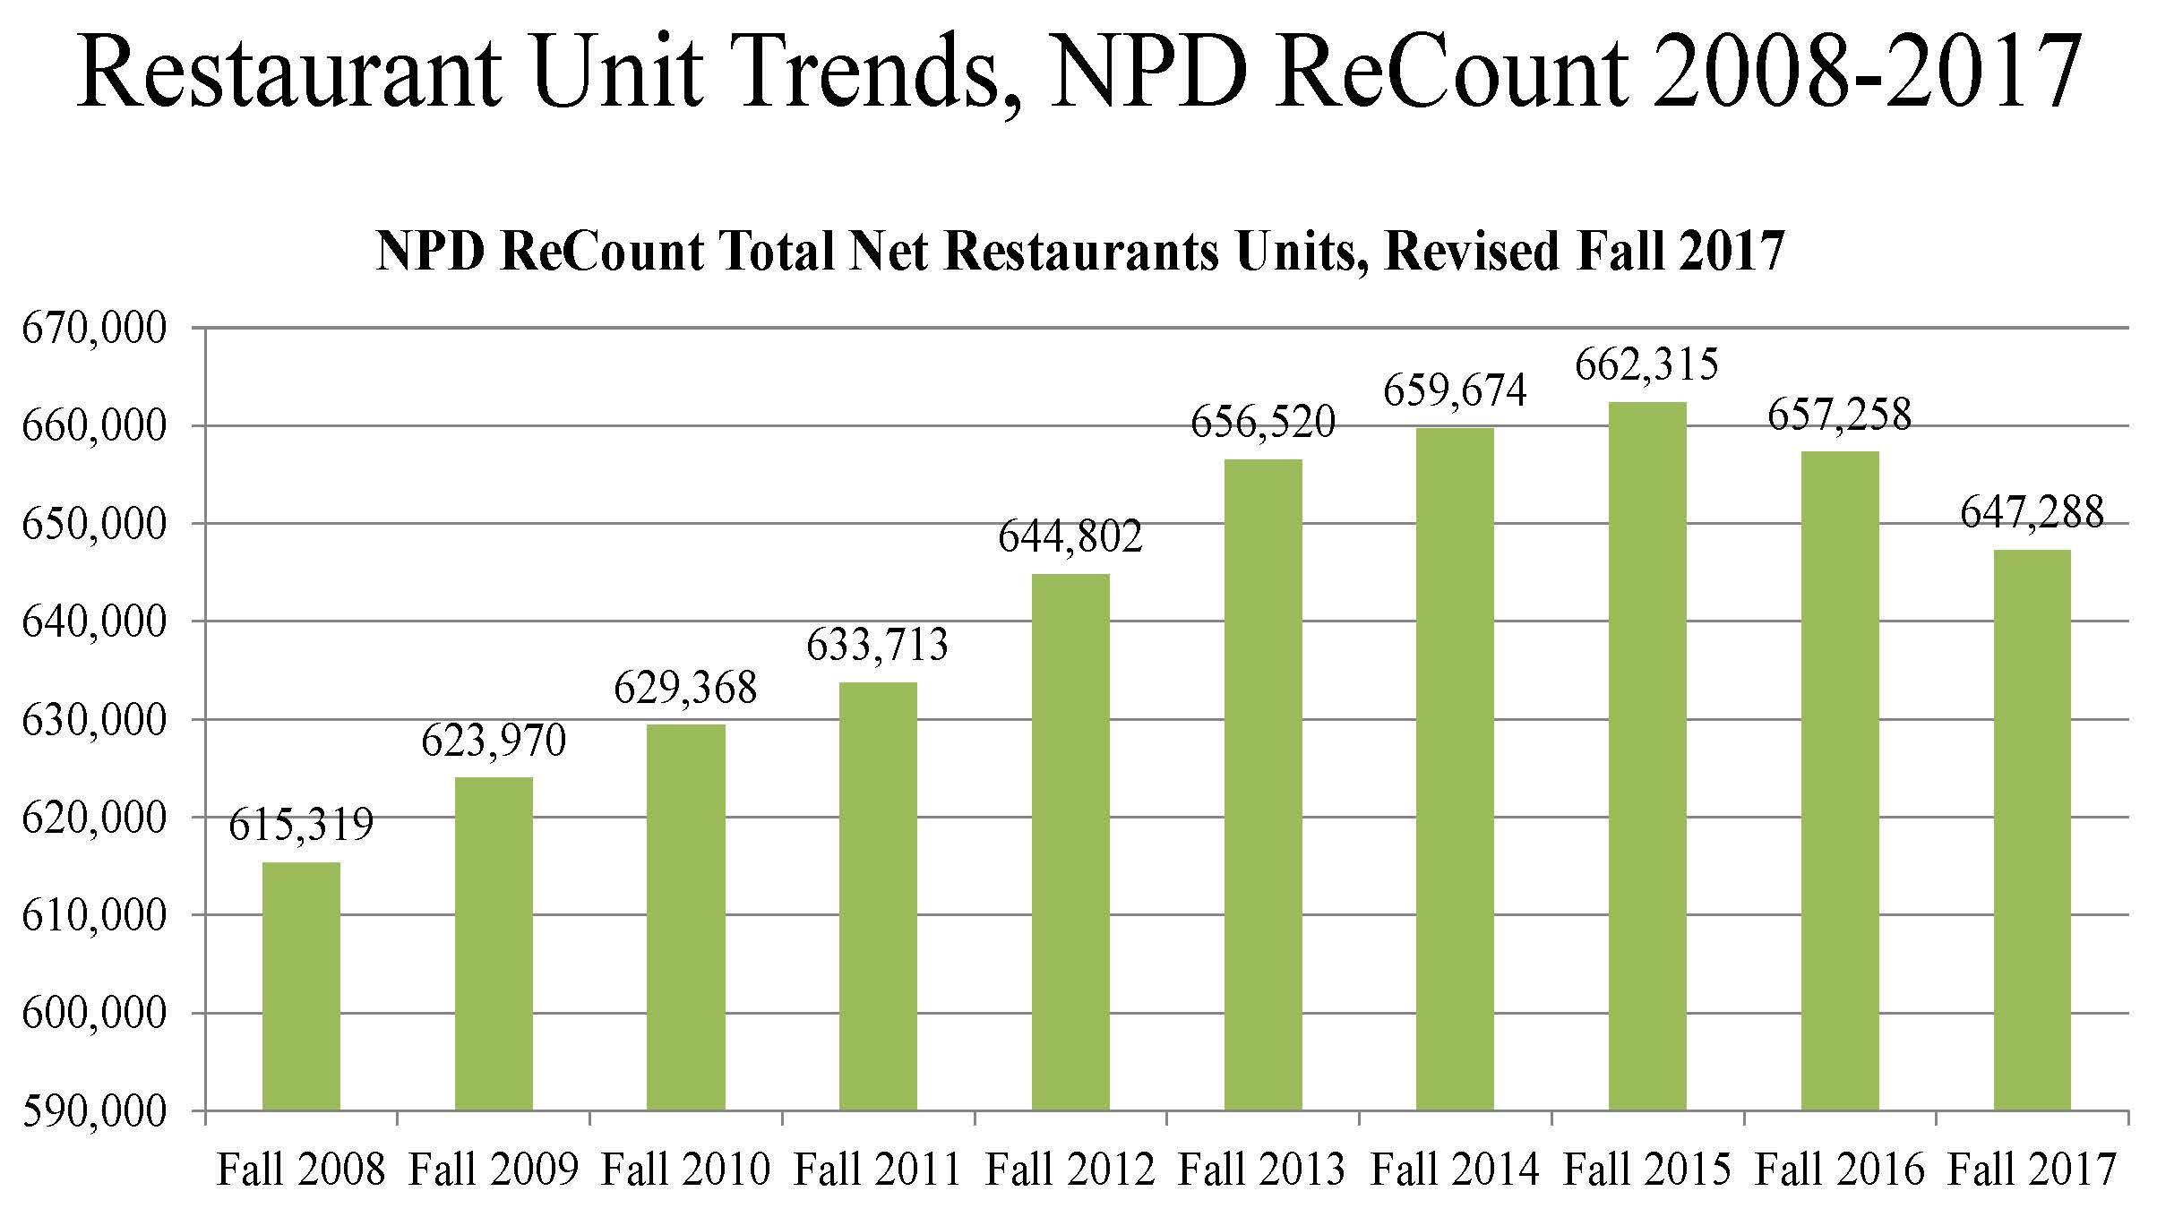

The truth is, our Keynesian central bankers are so focused on the primitive tool of interest rate pegging and the task of filling the bathtub of GDP to the brim of its wholly mythical potential output level that they completely fail to see the speculative madness--like this case of Chipotle---- they have fostered inside the canyons of Wall Street.

Thus, speaking to reporters today, San Fran Fed President Mary Daly said that US central bankers are currently debating whether it should confine its controversial tool of bond buying (QE) to purely emergency situations or if it should turn to that tool more regularly:

*“In the financial crisis, in the aftermath of that when we were trying to help the economy, we engaged in these quantitative easing policies, and an important question is,****should those always be in the tool kit — should you always have those at your ready — or should you think about those are only tools you use when you really hit the zero lower bound and you have no other things you can do,****” Daly said after a talk at the Bay Area Council Economic Institute.*

*So how would the Fed decided which "tool" to use when? Well, according to Daly the answer wasn't clear: "you could imagine executing policy with your interest rate as your primary tool and the balance sheet as a secondary tool, but one that you would use more readily,” she added. “****That’s not decided yet, but it’s part of what we are discussing now****."*

There you have it. These folks have been performing a classic Einstein insanity act-----doing the same thing over and over and expecting a different result----and now they are actually discussing doubling down.

In Part 4, we will show that the only possible outcome from this fetishistic focus on managing, pegging and suppressing interest rates is a final blow-off collapse of the immense speculative distortions and excesses that the Fed has spent decades fostering in the canyons of Wall Street.